Business Architecture Modeling in Brief

Introduction
This paper provides a brief summary of modeling and meta-modeling aspects of the core concepts of business architecture as defined in the BIZBOK® Guide, a publication of the Business Architecture Guild. The core concept areas are: value mapping, capability mapping, information mapping, organization mapping and cross mappings between these concept areas.
The representation of a business in a model is usually based on a selected perspective on the business. For example BPMN models represent the processes of a business, BMM models represent the strategic thinking that guides the business, and various other models represent the structure and behavior of information technology that supports the business. In addition, there are hundreds of works that describe strategic and analytic methods that have been applied to improve the success of businesses. Many of these works have implied models that have never been formalized, but could be.
Business architecture is a title that was given originally to methods and models for integrating and cross-mapping information contained in business models of various types, in order to create a more complete model of a business. The Business Architecture Guild was formed to unify these methods and to build a community of practice around the unified method.
The Business Architecture Guild believes that the method and its models are sufficiently mature and stable to warrant the standardization of a meta-model for business architecture that builds on and integrates common business strategy and analysis methods, especially those with existing standard meta-models or for which a meta-model can be easily defined.
A key problem in model integration is the specification of an integrating model that can be extended to include selected concepts from other models. While there are likely many such models, the Business Architecture Guild has chosen a set of “core” models that have value themselves in supporting business analysis and strategy in addition to their suitability as integrating models. These models cover the core concept areas of value mapping, capability mapping, organization mapping and information mapping.

Meta-challenges

Model construction and analysis versus presentation
Presentation style is an important element of virtually every description of a business method. Presentation styles are carefully tailored to make it easy for the decision maker to understand the findings and to act. Because presentation styles emphasize certain perspectives over others, there is the danger that a wrong decision will be made because relevant findings were not emphasized in a style.
Presentations are typically projections of an underlying model. The model is inevitably constructed in an incremental fashion as information representing different points of view is accumulated and added to the model. It is easy to see how a complete model can be projected to create a presentation; it is much more challenging to define a meta-model that allows incremental model creation by synthesis of views.
However, the OOram (Reenskaug 2001) method and model used a synthetic approach for the creation of OO models, and its meta-modeling principles may be useful in meeting this challenge.

Model completeness
Using models to perform analysis can lead to incorrect findings if the models are incomplete. One of the objectives to model-based analysis should be a determination of model completeness. This test can partly be done by defining meta-modeling rules for structural completeness. But, the real test must compare the predictions of the model with the structure and behavior of the enterprise being modeled. The meta-model must be extensible to allow instantiated models to be analyzed for completeness.

Integration techniques
There are two approaches to integrating business models: conceptual integration and model element integration. Conceptual integration makes use of prose and diagrams to illustrate how the concepts and relations in two or more models relate to each other. Model element integration seeks to link together the data representations of the model elements and relations. Model element integration implies a corresponding conceptual integration and is capable of supporting automated analysis.
Model element integration is challenging because in existing business modeling tools, there is no common, stable representation of identity. The identity of a model element is unique within the model fragment (file) only and the model editing processes within the tool may change this identity unnecessarily (i.e. by destroying an existing model element and creating a new model element representing the same concept as represented by the destroyed element) in the course of changing the model. This is not entirely the fault of tools; modelers are often make use of identity destroying but expedient editing practices to change model representations that are found to be incomplete or inaccurate.
This paper suggests an approach to model element integration that makes use of proxy identities. Realizing that it will not generally be easy or possible to extend a commercial tool’s model, the entire burden of integration will fall on the business architecture model. Since integration is accomplished by mapping model element identities, this means that the business architecture model must include proxy identity elements that represent model element in foreign models and contain the foreign element model identity or identities as properties of the proxy identity elements. It is convenient to assume that these properties are represented as IRIs as this allows the use of common software to attempt to resolve the referenced foreign model element. An implication of this approach is that the type of the proxy identity model element in the business architecture model must subsume the type of the model element in the foreign model. The term “type” here means logical entailment.

Capability Mapping

Concepts
From the Ulrich Homann paper:
So, we find that the real question is "When you architect a solution for your customers, which elements of that architecture are really durable and allow you to deal with change?" Because that answer obviously provides the best ROI and the best insurance against architectural obsolescence.
What we have found is that the stable elements are much more about what businesses actually do (for example, create purchase orders, generate invoices, ship products, and so on). These business activities, which we refer to as business capabilities, are relatively stable, but how businesses implement them with people, procedures, and technology, and how those activities knit together into processes, is far less stable. So now, we need to find out what a business does, what its capabilities are.
Before we continue, let's introduce a few definitions for our discussion:
- A business capability is a particular ability or capacity that a business may possess or exchange to achieve a specific purpose or outcome. A capability describes what the business does (outcomes and service levels) that creates value for customers; for example, pay employee or ship product. A business capability abstracts and encapsulates the people, process/procedures, technology, and information into the essential building blocks needed to facilitate performance improvement and redesign analysis.
- Capability connectors represent the links that exist between business capabilities. Connections are not just simple messages; they contain rich semantic information. There are a variety of connectors in the capability model that focus on information exchange (input/output, supporting information), and control or establishment of policy (regulatory influences).
- Business processes describe how the business performs, or implements, the given capability, or how capabilities connect to deliver a desired outcome. Hammer and Champy, authors credited with creating the business process movement in the 1990's, carefully define business processes as end-to-end work elevated above procedures. Processes transcend organizational departments and functions.
- Business capability mapping is the definition and clear structural outline of the capabilities and their connections that drive the activities of a typical company. Business capabilities are the building blocks of the business architecture, so thinking of capabilities as an architectural blueprint is a good analogy, whereas the process is the implementation of that architecture at any given time. Once this more objective and stable view of the business is established, companies can understand significantly more about dependencies between capabilities and get a much better understanding of the business: within a line of business, across business units, and over time.
Capabilities are hierarchically decomposable into sub-capabilities. The decomposition principles are sometimes based on capabilities associated with a particular business object (akin to the Responsibility approach to OO design), but may be based on other factors such as similarity of skills. Hence, the meta-model may not constrain the nature of the aggregation relationship.
Capabilities may be tagged. For example, capabilities may be tagged as executive, operational, and support. Often these tags may be used to create the top layers of a tree graph presentation. In some cases, the tags appear to be capability types, while in other cases they are simply classifying characteristics. The tags may or may not align with the hierarchy (in some methods, they are required to align with the hierarchy).
Capabilities produce outcomes. An outcome may be tangible or intangible. Other capabilities may depend on these outcomes. This construction gives rise to a capability/outcome network. In manufacturing enterprises, the outcome may be a tangible item such as an integrated circuit. In information process enterprises, the outcome is typically an information item (embodied as a report or graph created from electronic data).
Capabilities may be tagged. The tags are typically used to create presentations in which the capabilities or outcomes or both are colored to indicate some analytic findings or a particular nature. The tags will typically represent an analytic finding, the method used to produce it, and the parameters used in the application of the analytic method. From a meta-modeling point of view, tags are complex model elements.

Modeling
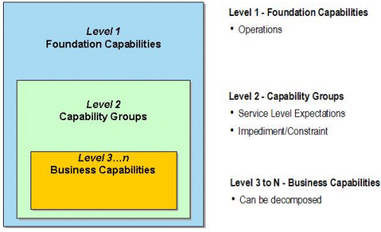

Comments
Capability models have been independently proposed by several groups, notably Microsoft and IBM (Price-Waterhouse-Coopers). The hierarchy construction principles differ in the several variants in use today. The Microsoft model specifically states the goal of having a functional model that did not change when the shape of the business organization changed.
In the BIZBOK® Guide version of this model, we explicitly represent the “rich semantic links” that Homann mentions as “outcomes” that are created by capabilities and then facilitate or enable other capabilities. These outcomes enable a lot of analysis about effective collaboration in the organization.

Value Mapping

Concepts
Three approaches to modeling value are described and compared in the BIZBOK® Guide:
- Value Chains (Porter)
- Value Streams (Whittle and Myrick)
- Value Networks (Verna Allee)
There is a fourth possible form that is the value tree that may be considered useful when the value creating activities add value by aggregation and integration of items that have individual value to stakeholders.
Porter’s Value Chains are assumed to be well-understood.
Whittle and Myrick define a value stream as “an end-to-end collection of activities that create a result for a customer, who may be the ultimate customer or an internal end-user of the value stream”. The value stream approach depicted below, focuses on creating higher level value stages whereby each stage adds value to the customer. In a sense, we can see the value stream approach as leaving the Porter approach of five core activities as simply a special case of the more general approach.
In the BIZBOK® Guide presentation of this material, Whittle and Myrick’s customers are called stakeholders.
Value streams are decomposable. A value stage may be decomposed into a sequence of lower level value stages. This is done mainly to deal with the inconvenience of representing in graphical form a value stream with more than 10 stages. A value stage that is decomposed in this way is not obliged to have stakeholders triggers or value items other than those associated with the decomposed value stages. Thus, a decomposed value stage is not a value stream.
Value stages may be shared by several value streams. This sharing is explicit in value network models and implicit in value streams. In a top level value chain model, there is no sharing because the value chain of the entire enterprise is shown, even when the enterprise may produce multiple items of value. In this case, it is typical to define individual value chains for each business strategy (business model) since different strategies (e.g. innovator, low cost producer, reliable supplier) may emphasize different parts of the value chain. Kaplan and Norton extend this idea that was pioneered by Porter in strategy maps.
Value networks depict exchanges of value between roles where roles are nodes in a graph and the value exchanges are directional arcs that connect the nodes. There are ongoing discussions with Verna to determine whether roles and stakeholders are equivalent concepts; they are clearly related, but equivalence is a much stronger claim.
These models all have a common underlying set of concepts: the notion of value producing activites, the notion that groups of value producing activities are related by consumption of value produced by another group of value producing activities; and the notion that the produced value can be described. Assuming for the moment that stakeholders and value network roles are equivalent, then the value stream, value chain and value tree are technically projections of the value network. The methods used to establish these models are often quite different and when applied to the same enterprise may lead to incompatible models. From the perspective of the meta-modeler or tool builder, this is of little consequence, so long as the required models can be instantiated from the meta-model.
Finally, note that the value stream model identifies a stakeholder and a description of the value (value item) that is produced for the stakeholder. This value item is not the thing that is produced by the value activities, but is an interpretation of the value associated with the thing that is produced. Value items may be (and typically are) non-quantitative. In value networks, the value item is not explicit in the graph but is usually made explicit in the associated narrative and/or spreadsheets. These are presentation differences, intended to render different perceptions of the model.

Models
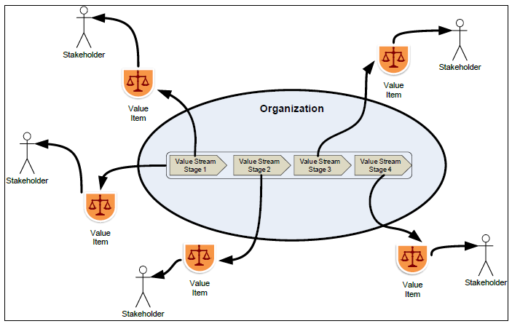

Comments
Some value exchange models (e.g. REI) define a causality coupling between value exchanges. This coupling is not present in presentation models of value chains, value streams or value networks. Where a causal coupling exists, it is typically described in the narrative accompanying the presentation model. Causal coupling is challenging to model in enterprise value analysis. Typically the produced value is displayed in a value chain or value stream as an accretion of value across the value stages, with each value stage having its existence justified by adding significant value to the final stakeholder and providing a significant value to intermediate stakeholders. The received value, on the other hand, is immediately received by one stakeholder and distributional techniques are used to allocate the received value among the other stakeholders, often according to a costing analysis.
Business architecture does not provide direct models for cost/benefit analysis; the practitioner will typically use one of the established approaches for this analysis. Interesting insights can be seen when cost/benefit analysis results are allocated to capabilities. Since capabilities may be performed by many organization units in an enterprise, the resulting combination of cost/benefit figures across multiple organization units may reveal capabilities in which the cost/benefit ratio is out of balance.

Cross-mapping Capabilities and Value Streams

Concepts
The Whittle and Myrick definition of value stages as a group of activities that produce value is incorporated into business architecture in the cross mapping of value streams and capabilities. In the presentation view, this cross mapping is an association of capabilities involved in the production of a value item of a value stage; an example is shown below.
In the meta-model, there is an aggregating association between a value stage and a capability. In addition, since capabilities have outcomes and value stages may have value items, there is normally an association between the value items of the value stage and some outcomes of the set of associated capabilities. For the purpose of analysis or presentation, only certain outcomes are associated with value items of value stages. Hence, this association must be constructed by the architect in conjunction with the construction of the cross map between value stage and capability. Semantic coherency demands that for each value item that is associated with an outcome, the corresponding outcomes must be outcomes of the capabilities associated with the value stage that produced the value item.
It can often be concluded that the stakeholder receiving the value item also receives the underlying outcome, but this is not always the case; consider, for example, the representation of a charitable donation.
Likewise, it may often be concluded that a stakeholder has a business interest in (and responsibility for) a collection of capabilities that produce the value items of a value stage, as this stakeholder receives the value items of the outcomes of capabilities associated with a prior stage in the value stream. But, this does not logically follow from the construction of the model and must be specified explicitly. It is not clear that stakeholder (as define in value mapping) and an entity with a business interest in the capabilities of a value stage are always one and the same (and thus equivalent). It is clear that the construction of the cross mapping between capabilities and value streams constraints the possible candidates for this business interest relationship.

Models
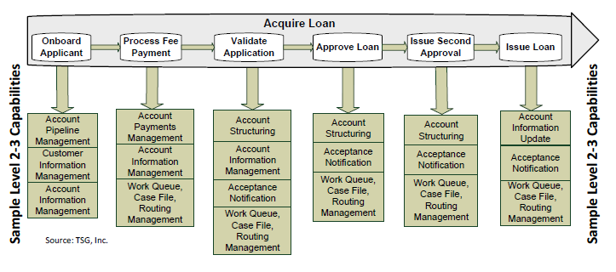

Comments

Information Mapping

Concepts
Information mapping in business architecture is done mainly to support operational and executive decision making. However, there are enterprises whose business activity is aggregation, analysis, selection and sales of information (newspapers, Bloomberg) where information is a direct product. The information map must serve both purposes.
The primary information mapping concepts are categories, exemplary individuals, values, properties and roles. A category is like a class, the individuals are class members, values are constants of various types (colors, numbers, time, etc.), properties are binary relationships between categories and values and roles are binary relationships between categories. The roles can be classified as having inheritance, as being an aggregating role, as being a containment role, and so forth.
Categories, value types, property definitions and role definitions can be combined in an information map to create patterns for the structuring of information (like the schema of a relational database). Combinations of individuals, values, properties and roles then represent information instances that conform to the patterns of categories, value types, property definitions and role definitions.
The information map also includes definitional rules which allow the creation of new categories and n-ary roles that are defined by restriction formulas over configurations of other categories, value types, individuals, values, properties and roles. For example, a “loss event” is a category defined by “being an event of a certain event type which causes a loss of value to an economic person who is determined to be insured against events of that event type”. In model terms, the “loss event” category is equivalent to a formula that selects events that meet the criteria established by the formula. The formula refers to other categories such as “loss”, “economic person” and establishes selection criteria requiring that the economic person experiencing the loss be the same economic person who is insured and that the type of the loss is the same as the type of loss that is insured.
Such definitional rules are often used to define history categories. For example, a “loss event history” is defined as “the sequence of loss events occurring during the period of time when a particular insurance policy is in effect that are determined to be insured by that policy”. The definitional formula in this case will select just the loss events.
Note that these definitional rules are not required to select any individuals or roles and that it may be possible to conclude additional rules by inspection of the rule definitions.
Information instances arising in the course of a capability/outcome map are often aggregations and/or augmentations and revisions of other information instances. These aggregations, augmentations and revisions are the provenance of the information instances (and support information governance – who has the responsibility/authority to perform these aggregations, augmentations and revisions). The nature of the information manipulation is determined by the corresponding capability, but the information model must also track the correspondence between information model elements in an information instance and the predecessor information model elements. For example, a report may be prepared which selects events happening during a certain period; those events appearing in the report are a subset of the larger set of events. Revisions often occur when new information indicates that previously received information was incorrect; tracking provenance in the model defines the processes the business uses to find and correct the information that was derived from the incorrect information.

Model Example
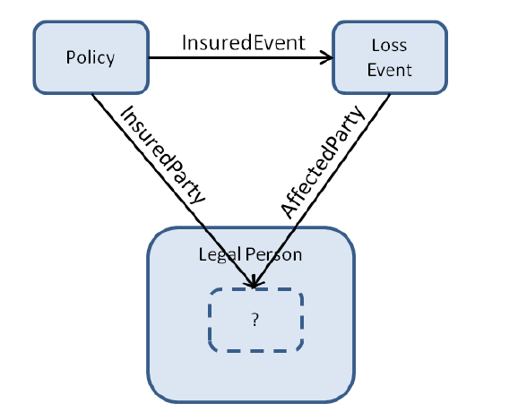
Multiple graphical presentation models exist, but few provide for expression of definition. These presentation models typically substitute the definition for the term and result in a large, flat model. On the other hand, constrained natural language models such as SBVR are capable of expressing quasi-logical formulas, including definitions.

Comments
The business architect creates the information map by interviewing people who are believed to be knowledgeable about the particular topic. However, different people often use the same natural language term to refer to different things, or use different terms to refer to the same thing. The business architect may thus determine that two categories originally thought to be different are in fact the same, or that a single category should be split into two or more categories. The model must allow for these kinds of changes.
The meta-model for information mapping could be defined using RDFS to provide the basic categories, value types, property types, role types, individuals and property values and using SPARQL to define the rules used to create new categories and roles (e.g. SPIN). Such a meta-model specification would have computational properties that are interesting (such as being able to produce the extension of categories and roles). As of 2014, the ability to translate arbitrary SPARQL queries into SBVR and the ability to translate some SBVR question patterns into SPARQL queries have been demonstrated. However, no complete formal proof of equivalence has been offered.

Cross mapping of Information and Outcome

Concepts
An enterprise may decide that it is important to record certain outcomes (e.g. sales) as data. Those outcomes will be associated with concept definitions in the information map that determine the corresponding categories, roles, properties and value types that are to be recorded. This association between outcomes and definitions in the information map is a specification for recording the outcomes but does not imply that the outcomes are actually recorded, or how to retrieve the data corresponding to the outcome recording..

Model Examples
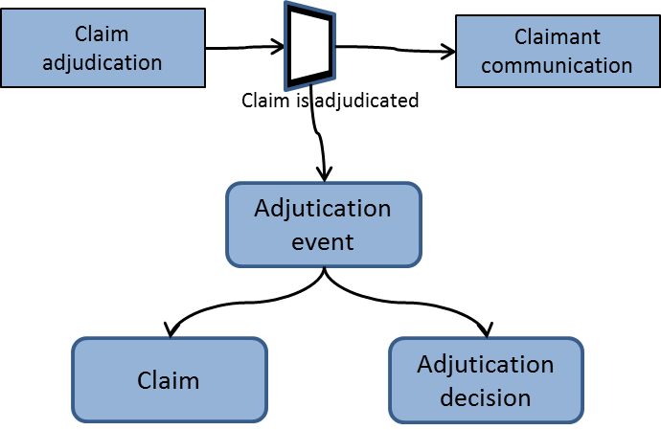

Comments

Organization Maps

Concepts
Each of the nodes in the following example model corresponds to a business unit. Organization maps can express many relationships between business units. The one below shows a decomposition relationship. Other relationships such as collaboration, information interchange and governance and responsibility may be expressed along with the decomposition relationship.
The collaboration relationship may be expressed as a relationship between collaborating business units and a new entity called a collaboration team. The collaboration team is logically composed of members from each business unit, together with the various business unit resources that have been designated as shared resources.
Organization maps are specific to a particular enterprise and a particular period of time. Changes that may occur over time include changing the names of business units, splitting and recombining business units, creating new business units and destroying current ones, outsourcing and insourcing business units, creating and destroying collaboration teams, changing their names, and splitting and recombining them.

Model Examples
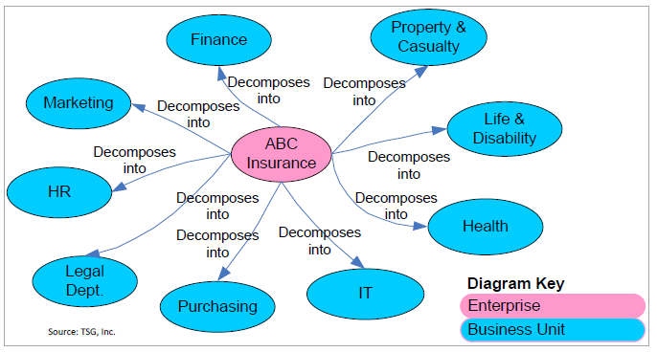

Comments
Collaboration teams are often associated with strategy initiatives and related projects.
There is a likely relationship between a collaboration team and one or more capabilities.

Cross mapping Capability and Organization

Concepts
Business units may be associated with capabilities. The meaning of such an association is that the business unit implements the associated capability, i.e. there are resources and skills assigned to perform the work described by the capability.

Model Examples
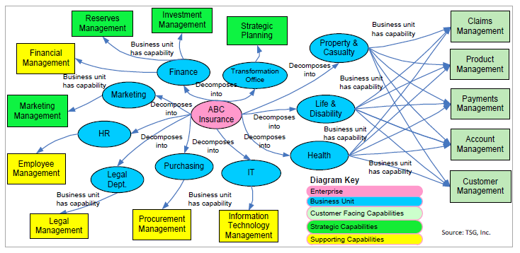

Comments

